**Assignment 01 – Ansible**

* Deploy three (3) Virtual Machines
* Configure Ansible server on ***VM 1***to deploy a webserver *to****VM2***and ***VM3***on port 8080 that displays the message: “Hello World from SJSU”
* Include in the Ansible playbook, plays to **deploy** and **un-deploy** all the webserver resources
* Due 9/12 (Sunday) at 11:59PM
* Submit a Word document via Canvas, with screenshots showing your work, and all ansible code/scripts via GitHub.

**GitHub repo:** <https://github.com/poojashreeNS/Assignments/tree/main/HW%231_Ansible/HW%231_By_Avinash>

**Deploy 3 Virtual Machine running Ubuntu OS using *Multipass Lightweight Virtual Manager(***[***https://multipass.run***](https://multipass.run) ***)*.**

***The best part of multipass is, it takes just a few minutes to install and run VMs compared to Virtual Box.***

**COMMAND:**

**multipass launch -c <<no.of.cores>> -m <<memory>> -d <<disk storage>> - n <<name of the instance>>**

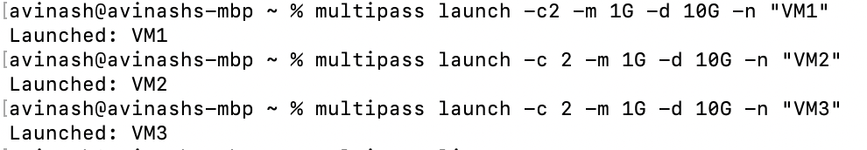

**Check the Status of Virtual machine using multipass list command**

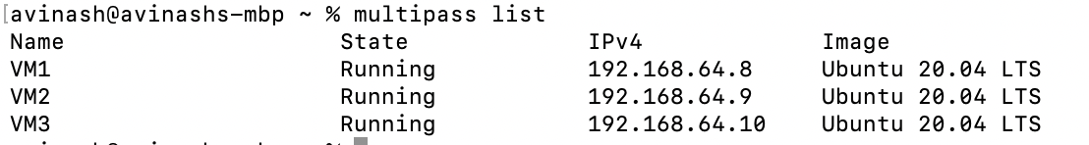

**Configure Ansible server on VM1**

**Login to VM1. IP Address: 192.168.64.8**

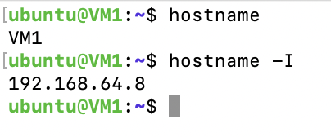

**Install Ansible in VM1**

**COMMAND:**

**sudo add-apt-repository --yes --update ppa:ansible/ansible**

**sudo apt install ansible**

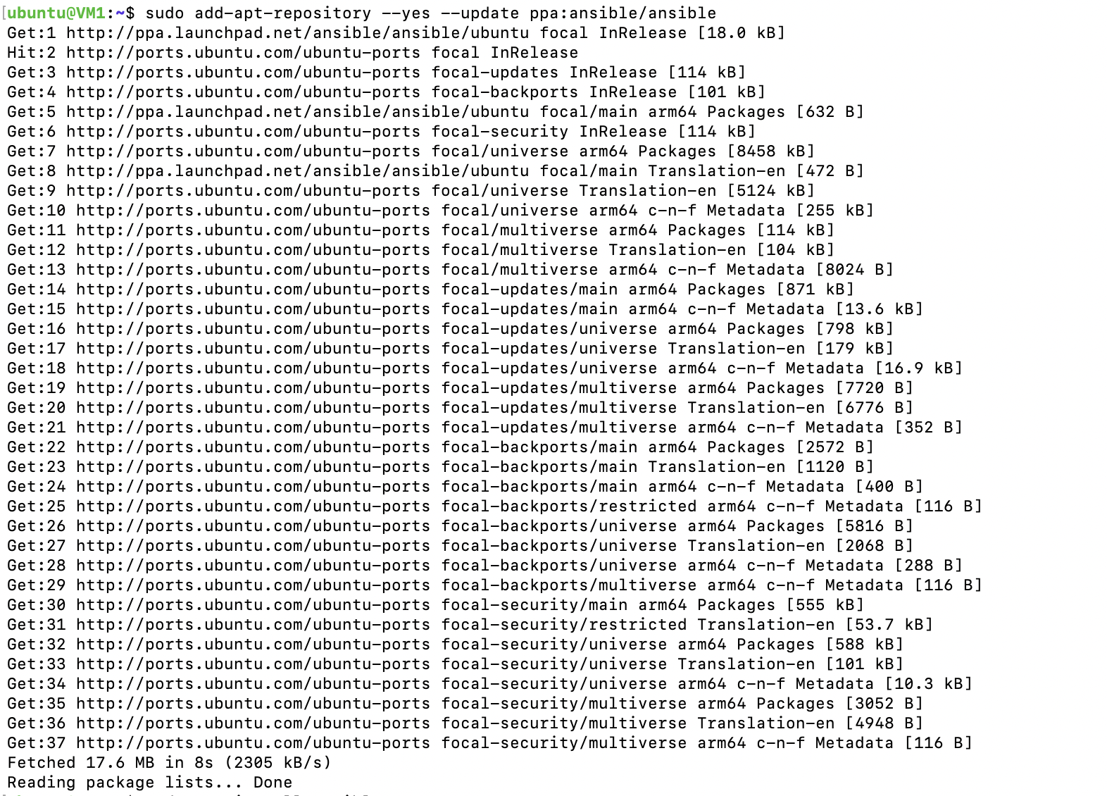

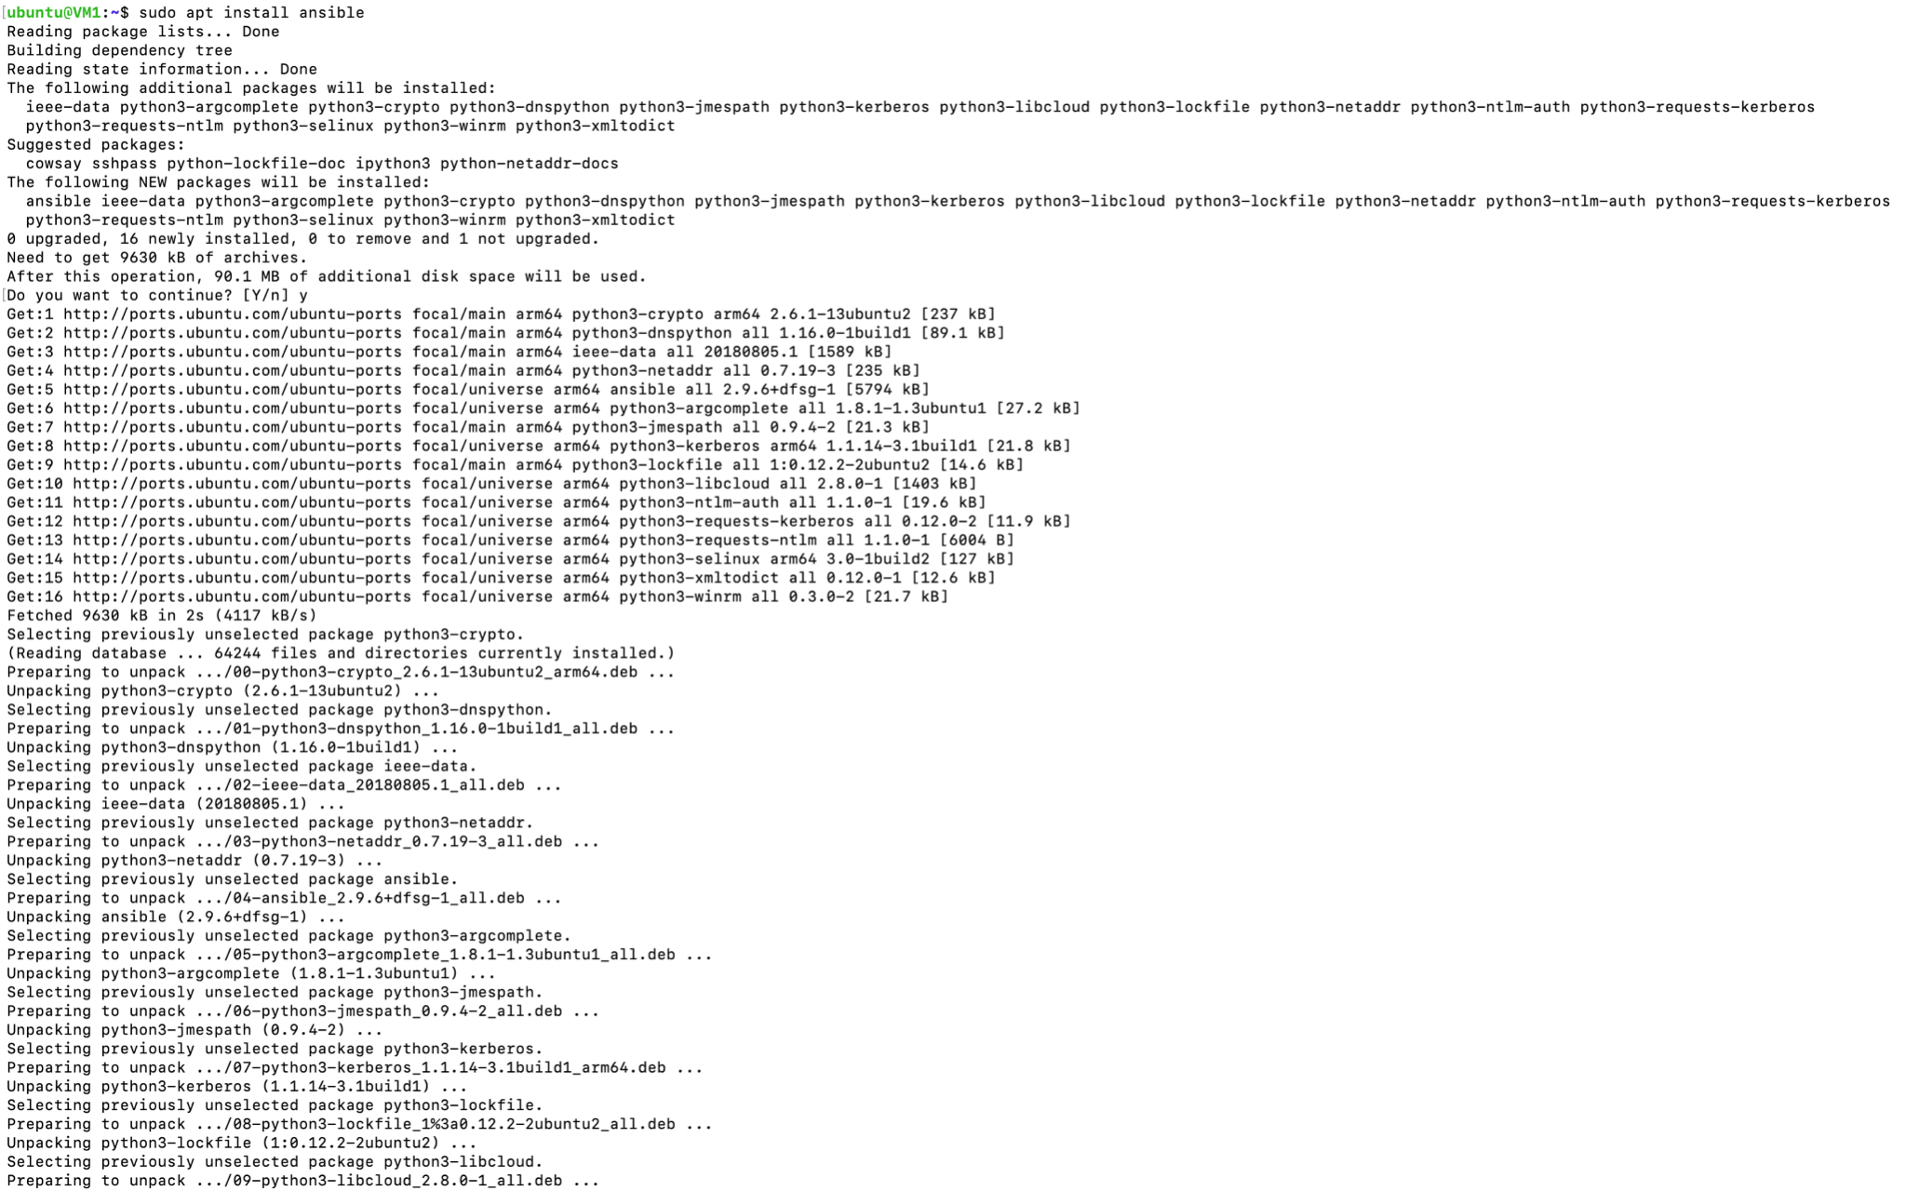

**CHECK ANSIBLE VERSION AND CONFIGURE CONNECTIVITY.**

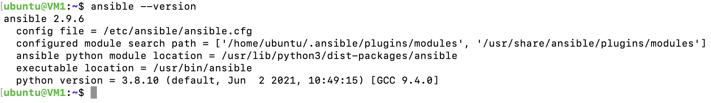

***Generate SSH Key for VM1 using either RSA OR ED25519 , add key to ssh agent and then add .Pub key of VM1 in VM2, VM3 under authorized_keys using ssh-copy-id command or copy paste directly under authorized_keys.***

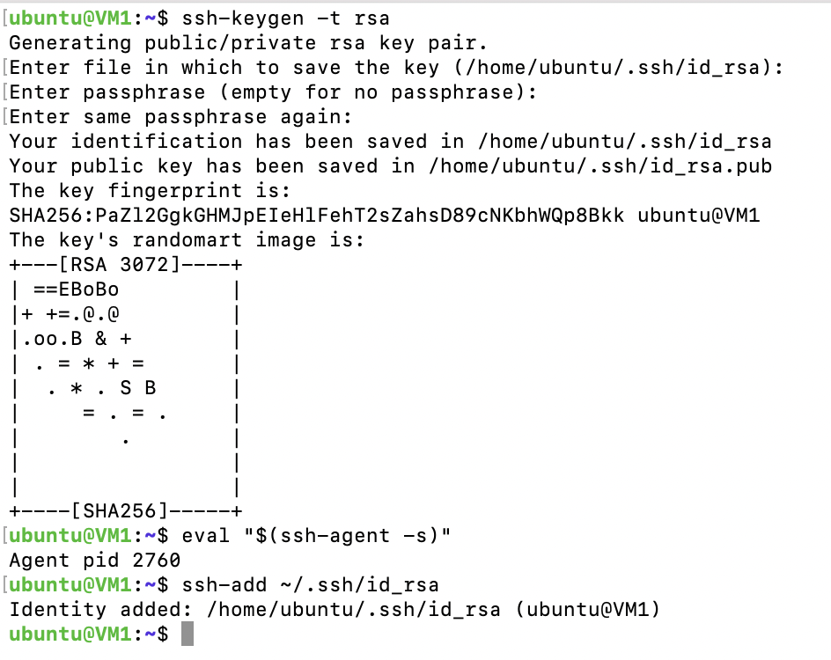

***Try password-less connecting to VM2 & VM3 from VM1 using the added key.***

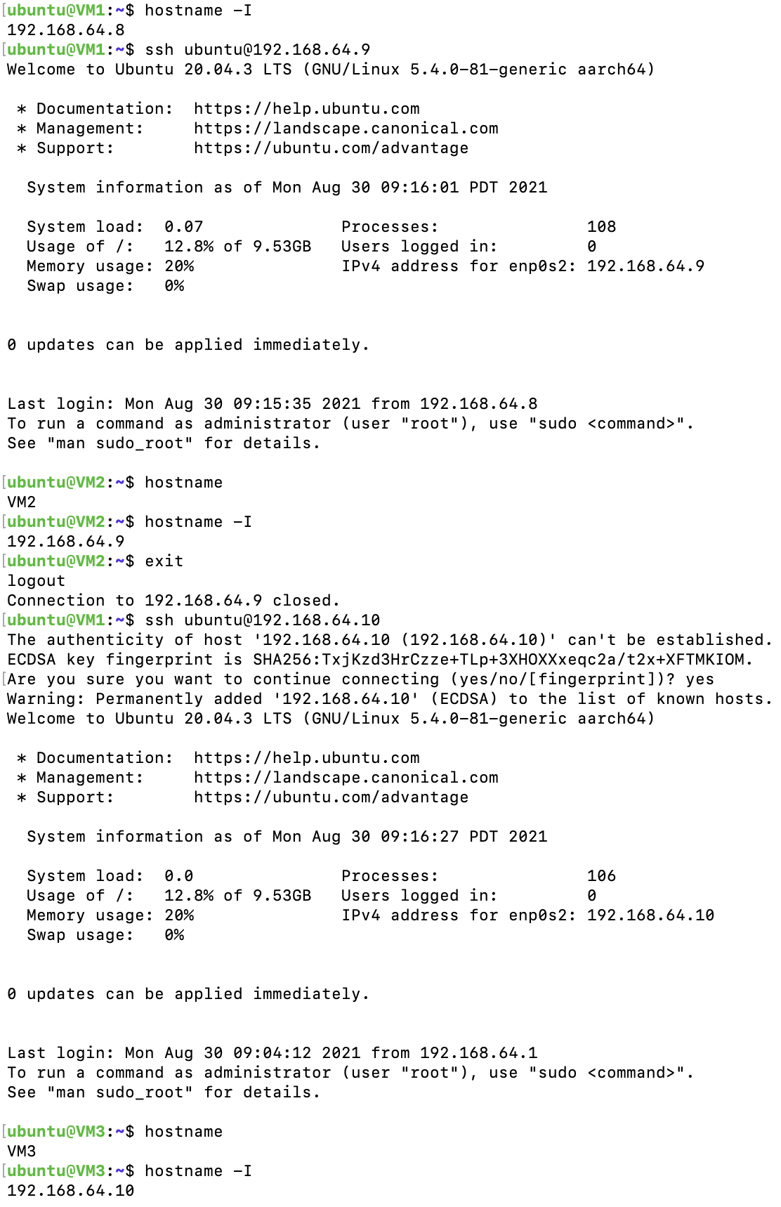

***Add Ansible hosts in VM1. The necessary IPs/hostname under: /etc/ansible/hosts.***

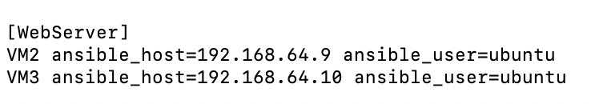

***Check ping***

***COMMAND:***

***ansible -m ping <<hostnames>>***

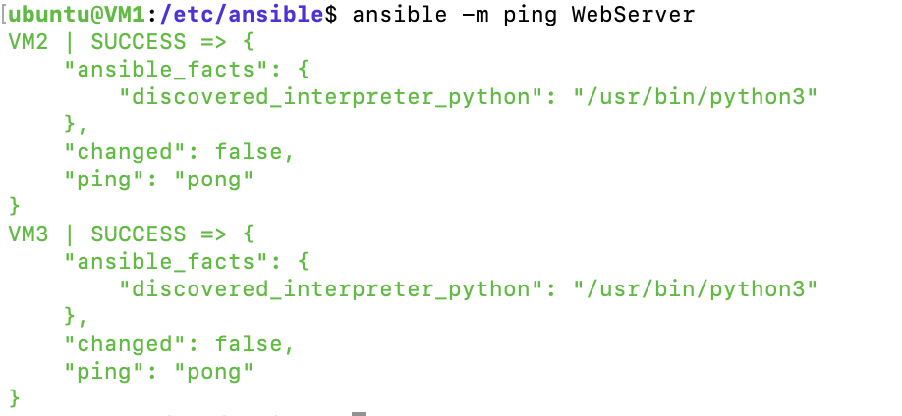

**DEPLOY WEB SERVER:**

***Create an .yml file to deploy apache web server in VM2,VM3 on port 8080 via ansible.***

***REPO:*** [***apache-deploy.yml***](https://github.com/poojashreeNS/Assignments/blob/main/HW%231_Ansible/HW%231_By_Avinash/apache-deploy.yml)

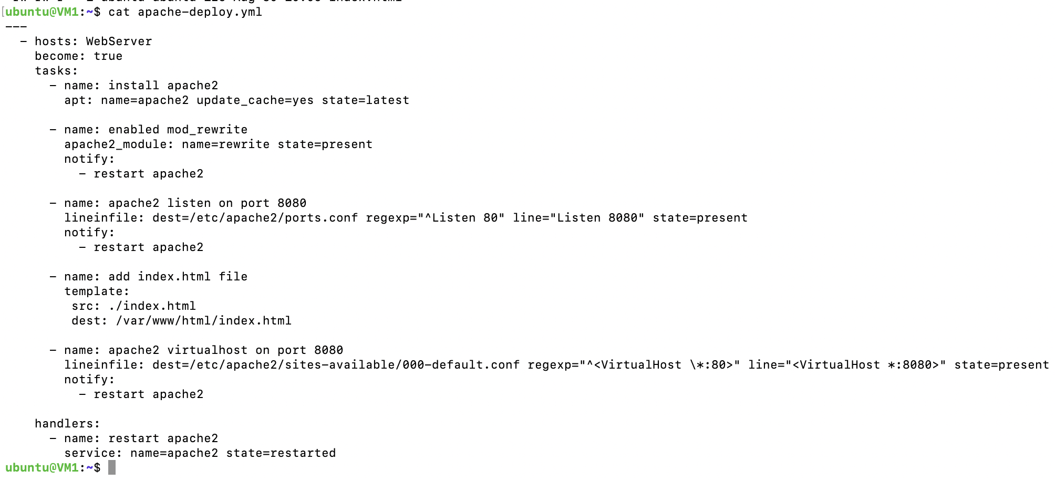

***Logs and output:***

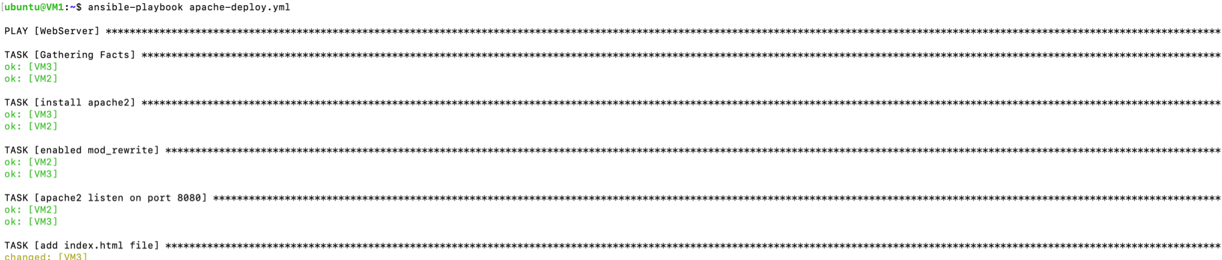

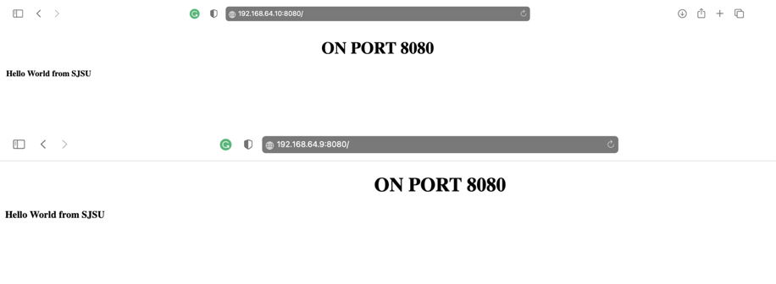

***Login to VM2 and VM3 and check whether apache is installed properly and files are present.***

***VM2:***

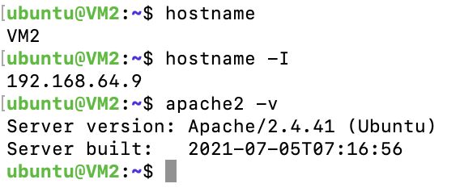

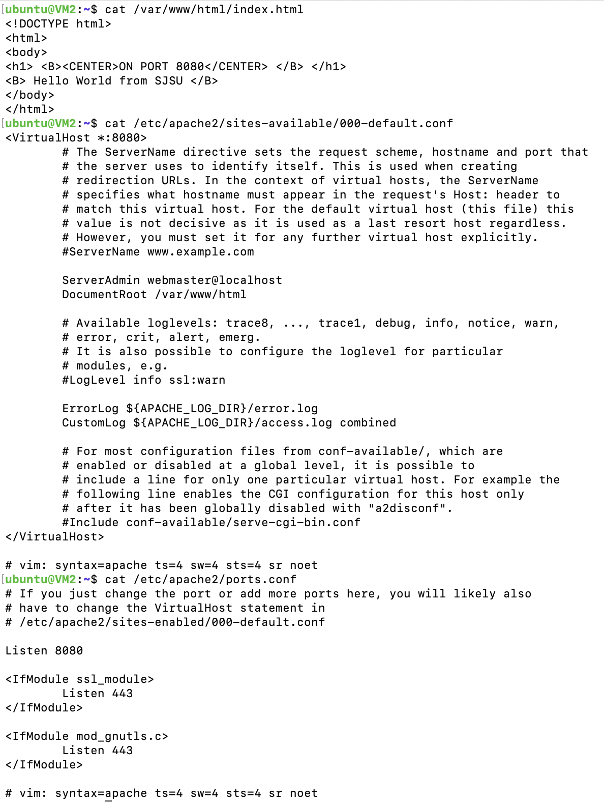

***VM3:***

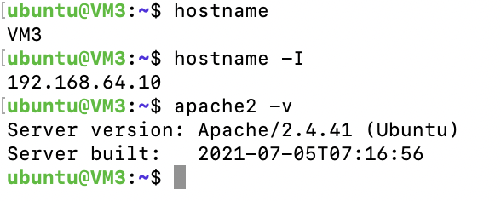

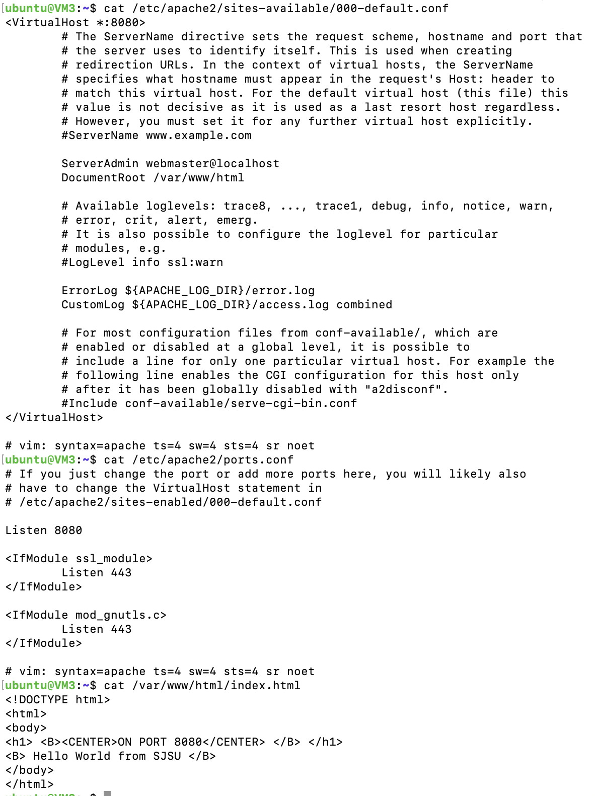

**UNDEPLOY WEB SERVER:**

***Create an .yml file to un-deploy apache web server in VM2,VM3 on port 8080 via ansible.***

**REPO:** [**apache-undeploy.yml**](https://github.com/poojashreeNS/Assignments/blob/main/HW%231_Ansible/HW%231_By_Avinash/apache-undeploy.yml)

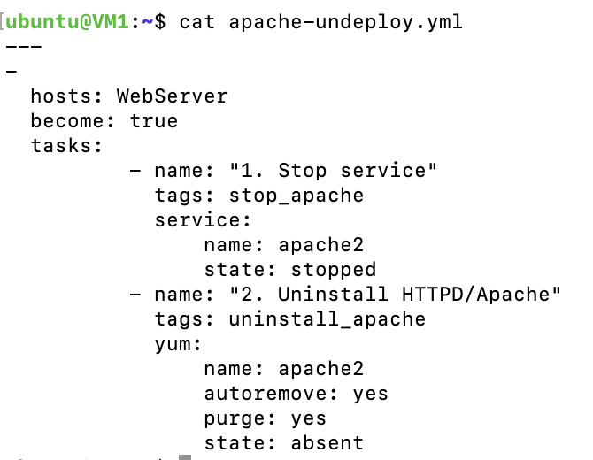

***Logs and output:***

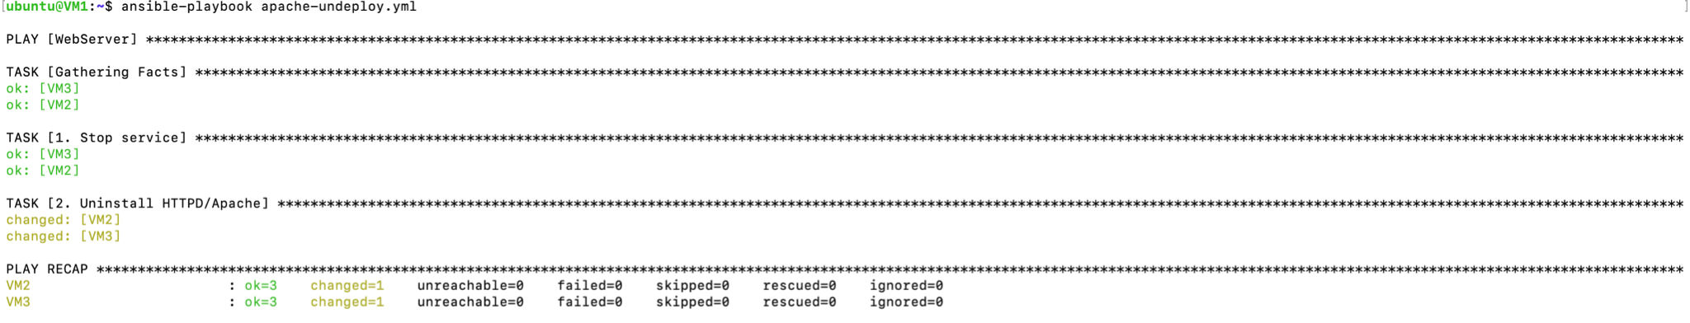



***Check if Apache is uninstalled and dependent files are Purged.***

***VM2 & VM3:***

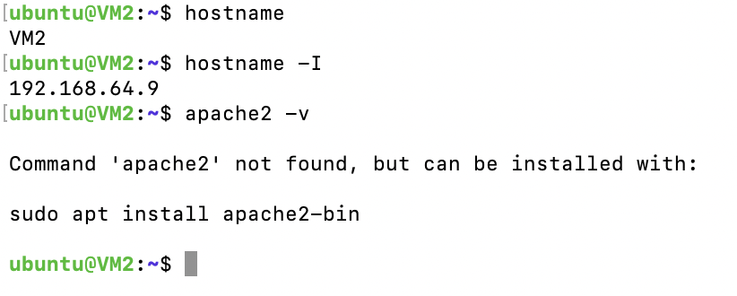

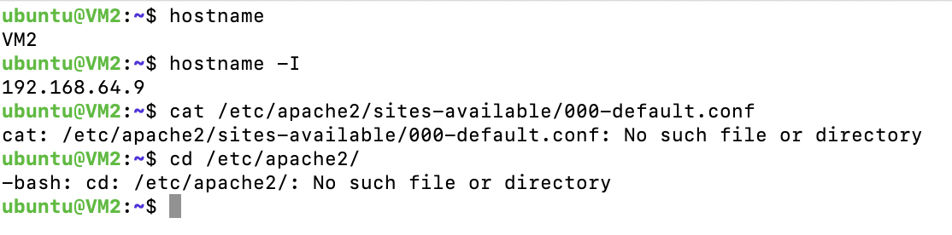

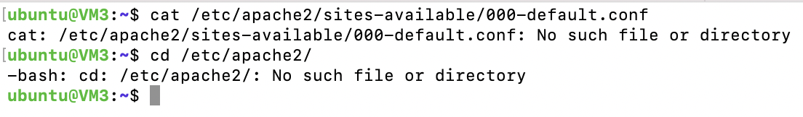

**References:**

[**https://www.bogotobogo.com/DevOps/Ansible/Ansible_SettingUp_Webservers_Apache.php**](https://www.bogotobogo.com/DevOps/Ansible/Ansible_SettingUp_Webservers_Apache.php)

[**ansible-intro-(ahb).pdf**](https://sjsu.instructure.com/files/64290603/download?download_frd=1)

[**https://multipass.run**](https://multipass.run)